# Image result for asia pacific college logo

# **Logistic System**

**Project Documentation Submitted  
To the Faculty of School of  
Computer Science and Information Technology  
of  
Asia Pacific College**

**In Partial Fulfillment of the Requirements for the subject   
Software Development**

**Heramia, Johanna Marisse Credito  
Gardon, Jana Marie Gavarra  
Tadeo, Jose Lorenzo Gonzales**

**April 2017**

Table of Contents

Logistic System 1

I. Introduction 3

a. Background of the Problem 4

b. Purpose and Description 5

c. General Objectives 8

d. Scope and Limitations 8

II. Review of Related Literature / Systems 9

III. System Diagrams 10

a. Event Table 10

b. Use Case Diagram 16

c. Context Flow Diagram 18

a. Data Flow Diagram 19

b. Entity Relationship Diagram 20

c. Data Dictionary 21

IV. Technical Background 35

V. User Manual 37

a. Administrators (National, Regional and City or Municipal) 37

VI. Conclusion and Recommendations 56

a. Lessons Learned 57

APPENDIX A – RELEVANT SOURCE CODE 58

APPENDIX B – REFERENCES 64

APPENDIX C – DEFINITION OF TERMS 66

APPENDIX D – CURRICULUM VITAE 67

# **Introduction**

Disasters are emergencies that cannot be handled by those affected without assistance. They are caused by natural or man-made events wherein communities experience severe danger and incur loss of lives and properties causing disruption to their social structure and to all or some of the affected communities’ essential functions. They are caused by unsustainable development that has not taken account of possible hazard impacts in that location. They can be less damaging if there will be system that can help the management in faster administering and management of different resources.

Now, in disaster, logistics is one of the most significant and complex component of the disaster operations whether if it is in preparedness, response or recovery phases. Logistics deliver the appropriate supplies in good condition, in the quantities required and at the places and time they are needed. Thus, logistics must be both agile and flexible in times of disaster and in preparing needed supplies, equipment and transportations.

Achieving those tasks of logistics is important because it can save and preserve millions and millions of lives in the disaster, and managing those are not easy and there is a need for a new, developed system that can handle those tasks and integrate different systems un users in just one click away.

# **Background of the Problem**

In general, common problems that need to address in disaster operations are lack of coordination within different agencies which leads to inconsistency of allocation and distribution of goods in different storage, lack of accuracy of information sharing, demands differs in disaster type, different sourcing of resources, damaged or lost infrastructure such as roads, utilities and communication, and competing demand (different priorities) because of multiple disasters.

Furthermore, there are two main problems of the logistics cluster that the system will address. First, facility location problem. It is important that the logistics knows where to locate new facilities such as factories, warehouses, distribution centers or supplier because logistics must know which facilities should be used or which victims should be served from which facilities to minimize the total cost and total time of serving the victims of disaster. Second, problem in vehicle routing. In disasters, there are big possibilities that many roads and infrastructure are broken or damaged, so logistics must know alternative routes and vehicles to be used to arrive in the destination in the right time and right condition of the supplies and equipment.

# **Purpose and Description**

***Management of Users***

Users have different access levels depending on what type of user they are. In ascending order, there are national admin, regional admin, city or municipal admin and external users. This module will help the administrators of the system in managing the records of users in various levels. Any administrator can see the basic information of all users. External users are not administrator, they are users that will request for supplies, equipment or transportation that is needed in the disaster.

***Map***

This map will help the user for faster identifying various places, establishments and more. Also, it will provide different alternative routes from a specific point to a specific destination. In addition, when the user clicks a location, he or she can see the information of the location.

Also, if the user needs supply, for example, a soap, the user can see the nearest location in the map where the needed supply is located.

***Reports Provider***

These reports will provide summary such as expiration report to track the supplies expiration in a particular warehouse, calendar reports wherein user can monitor the tasks or delivery that logistics needs to do or to transfer, pending/confirmed/in transit and arrived shipments reports that will monitor the distribution of the supplies in different areas.

***Management of Request***

This module will manage all the requests done by different users. The requestor can monitor the status of the request if it is: (1) Pending. If the request has not yet been confirmed. (2) Confirmed. If the request has already been confirmed but the supply is not yet on the way. (3) In transit. The requested supplies, equipment or volunteers are on the way but not yet arrived. (4) Arrived. If the requested supplies, equipment, or volunteers arrived. Also, the user will receive a respond from our system that contains the vehicle expected that is used in delivering the requested supply, who is person in-charged the delivery of needed supplies, and when will the supplies will arrive.

***Management of Donation***

Since donation is important also in times of disaster, this module will manage all the donation in outside or inside the local community. This donation can be from international, local, public government, private sector and so on. The user will input required information and the administrator will see the lists of donations. Donor will also receive a respond from the donor containing the information of a person in-charged in collecting the donation.

***Management of Records***

The records contain number of population and affected area, disaster sites, supplies, supplier, volunteers, warehouses and vehicles. These records can be updated, deleted and viewed depending on the level of access of the user.

***The following are the four different targeted users of the Logistics System:***

* **National Admin** – Manages overall data and operations. Receives requests from lower administrators.
* **Regional Admin** – Support disaster victims asking for the supports from the central government organizations and agencies. They get agreements with the cooperative organization of trucking companies or that of warehouse companies.
* **City/Municipal Admin** – They asses the needs of disaster victims, manage the depots of relief goods set up after disaster occurred, distribute relief goods to the disaster victims, reply to the offer of donated goods, and so on.
* **External users** – such as users of Law and Order, Dead and Missing, Monitoring, Food and Non-Food, Camp Coordination, Procurement, and Inventory Systems. To sum up the external users, the assessment from the disaster site will be done by Law and Order. Then, the assessment will be pass to Monitoring. Assessment contains all supplies, equipment, volunteers or transportation requested by different users. The Monitoring will then pass those records to the Logistics. Logistics will process all the requests and transfer the supplies, to the disaster area. If the stored supplies are not enough, then the Logistics will request to the Inventory.

# **General Objectives**

* To provide records of data or information such as locations, descriptions or information of warehouses, records of requests, supplies, suppliers, volunteers, disaster sites, population, users, and vehicles. Logistics system will automatically get such data from different system and integrate it in one system for different purposes.
* To provide maps for faster location of nearest establishments, alternative routes, travel time, camps, nearest transportation, nearest volunteer groups, ports and so on.
* To provide easier tracking of supplies whenever there is a need to request if the quantity reached its critical level.
* To provide easier requesting and responding to requests of users.

# **Scope and Limitations**

* The recovery phase is not included in the system.
* The maintenance of warehouses and vehicles are not part of the system.

# **Review of Related Literature / Systems**

***Disaster Emergency Logistics system for ASEAN***

“The Disaster Emergency Logistic System is developed to ensure a quick availability of emergency relief items that can be accessed by member states following medium to large-scale disasters” - Executive Director of AHA Centre

***Sahana***

The Sahana Software Foundation is dedicated to the mission of saving lives by providing information management solutions that enable organizations and communities to better prepare for and respond to disasters. We develop free and open source software and provide services that help solve concrete problems and bring efficiencies to disaster response coordination between governments, aid organizations, civil society and the victims themselves.

# **System Diagrams**

# **Event Table**

***National Admin***

|  |  |  |  |  |  |
| --- | --- | --- | --- | --- | --- |
| Event | Trigger | Source | Use Case | Response | Destination |
| National admin adds users | Request for new user | National Admin | Adds users | User account | National Admin Regional Admin External Users |
| National admin adds warehouses and its information | Request for new warehouses | National Admin | Adds warehouses and its information | Records of warehouses | National Admin |
| Map determines possible or alternative routes and location | Searches location and route | Map | Determines possible or alternative routes and location | Routes and location | National Admin |
| Inventory and procurement gives records of supplies and its suppliers | New records of supplies and its suppliers | Inventory System Procurement System | Gives records of supplies and its suppliers | Records of supplies and suppliers | National Admin |
| National admin distributes record of supplies to regional warehouses | New records of supplies | National Admin | Distributes record of supplies to regional warehouse | Records of supplies | National Admin Regional Admin |
| National admin receives updates from Logistic System of regional admin about the deployed items | Update request | Regional Admin | Receives updates from Logistic System of regional admin about the deployed items | Updated list of supplies | National Admin |
| National admin requests for supplies to inventory | Supply request | National Admin | Requests for supplies to inventory | List of supplies | Inventory System |
| National admin provides calendar and can add task | New task | Calendar | Add task/s in the calendar | Tasks | National Admin |

*Table 3, Event Table National Admin*

***Regional Admin***

|  |  |  |  |  |  |
| --- | --- | --- | --- | --- | --- |
| Event | Trigger | Source | Use Case | Response | Destination |
| Regional admin adds city mayors account and external users account | New city mayor and new external user | Regional Admin | Adds city mayors account and external users account | List of city mayors and externals users | National Admin City Mayor External Users |
| Regional admin receives requests from other system | New request | National Admin City Mayor  External Users | Receives requests from other system | List of requests | Regional Admin |
| Regional admin checks records of supplies | Inquiry for records of supplies | Regional Admin | Checks records of supplies | Records of supplies | Regional Admin |
| Regional warehouse admin requests for transportation to the logistic system of city mayors and supplies to national admin | Vehicle requests Supplies requests | Regional Admin | Requests for transportation to the city mayors and supplies to national admin | Confirmation of request | City Mayor National Admin |
| Regional admin update logistic system about the deployed items | Update request | Regional Admin | Updates logistic system about the deployed items | Updated list of supplies | Regional Admin |
| Regional admin adds employee information | New employee | Regional Admin | Adds employee information | List of employees | National Admin Regional Admin City Mayor |
| Regional admin provides calendar and can add task/s | New task | Calendar | Add task/s in the calendar | Tasks | Regional Admin |
| Map determines possible or alternative routes and location | Searches routes or location | Map | Determines possible or alternative routes and location | Routes or location | Regional Admin |

*Table 3.1, Event Table Regional Admin*

***City / Municipal Admin***

|  |  |  |  |  |  |
| --- | --- | --- | --- | --- | --- |
| Event | Trigger | Source | Use Case | Response | Destination |
| City Mayor adds transportation information for barangays | New transportation information | City Mayor | Adds transportation information | List of transportation information | National Admin  City Mayor |
| City Mayor updates and deletes information | Delete and update request | City Mayor | Updates and deletes information | Updated and deleted information | National Admin City Mayor |
| City Mayor receives request | Request for confirmation | Regional Warehouse Admin | Receives requests | Confirmation of requests | City Mayor |
| City Mayor checks for the nearest barangay and available vehicles | Information inquiry | City Mayor | Checks for the nearest barangay and available vehicles | List of barangays and its vehicles | City Mayor |
| City Mayor confirms requests | Confirmation | City Mayor | Confirms requests | Confirmation of requests | Regional Admin |
| City mayor provides calendar and can add task | New task/s | Calendar | Add task/s in the calendar | Tasks | City Mayor |
| City mayor provides list of their supplies and volunteers | Supplies and volunteer information | City Mayor | Provides lists of their supplies and volunteers | Lists of supplies and volunteers | City Mayor |
| Map determines possible or alternative routes and location | Searches routes or location | Map | Determines possible or alternative routes and location | Routes and location | City Mayor |

*Table 3.2, Event Table City/Municipal Admin*

***External User***

|  |  |  |  |  |  |
| --- | --- | --- | --- | --- | --- |
| Event | Trigger | Source | Use Case | Response | Destination |
| External user checks for available supplies or vehicles | Information inquiry | External User | Adds transportation information | List of transportation information | National Admin  City Mayor |
| Map determines possible or alternative routes and location | Searches location and route | Map | Determines possible or alternative routes and location | Routes and location | External User |
| External user requests to city mayor for supplies or vehicles needed | Request for supplies or vehicles | External User | Request for supplies or vehicles to the city mayor | List of supplies of vehicles | City Mayor |

*Event Table 3.3, Event Table External User*

# **Use Case Diagram**

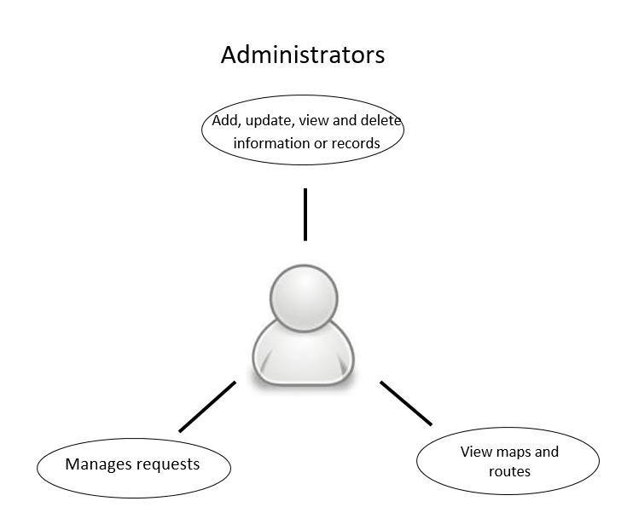

*Figure 3, Use Case Diagram Administrators*

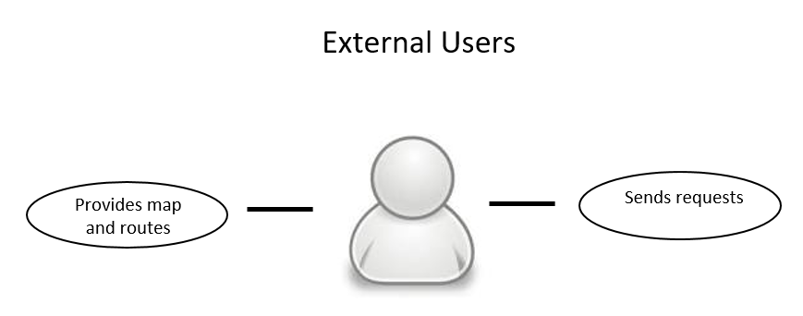

*Figure 3.1, Use Case Diagram External Users*

# **Context Flow Diagram**

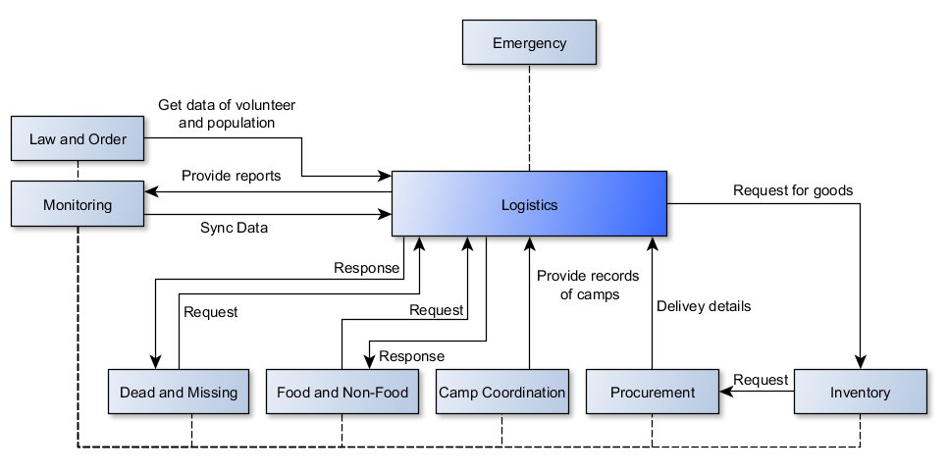

Figure 3.2, Context Flow Diagram

# **Data Flow Diagram**

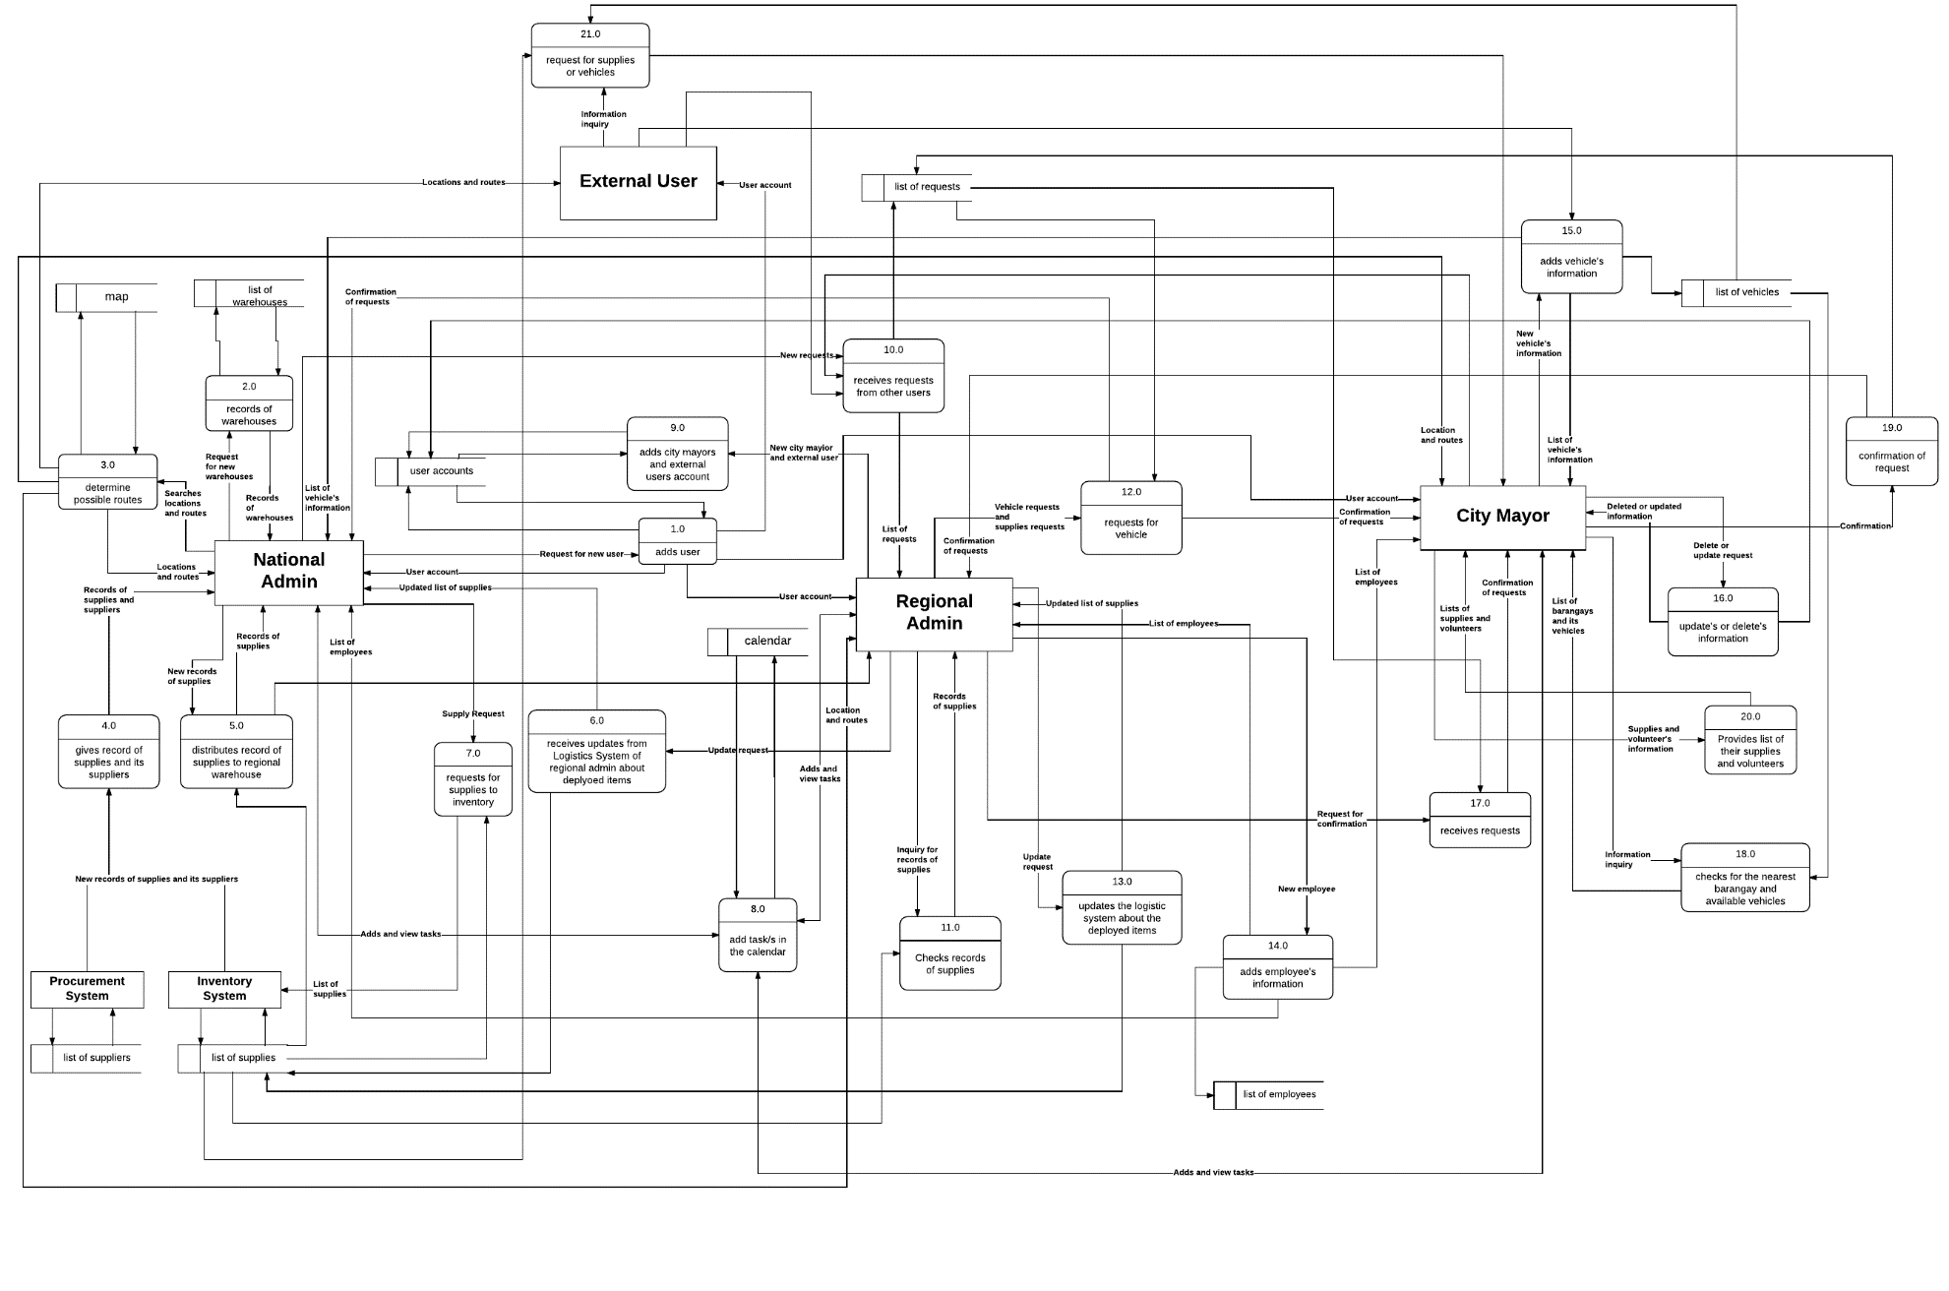

*Figure 3.3, Data Flow Diagram*

# **Entity Relationship Diagram**

*Figure 3.4, Entity Relationship Model*

# **Data Dictionary**

|  |  |  |  |  |  |  |
| --- | --- | --- | --- | --- | --- | --- |
| USER | | | | | | |
| FIELD NAME | **DATA TYPE** | **FIELD SIZE** | **KEY** | **NULLABILITY** | **DESCRIPTION** | **EXAMPLE** |
| id | integer | 11 | PK | NN | Unique identification number of each user | 2017-234567 |
| username | varchar | 255 |  | NN | Unique username of employee | jggardon |
| auth_key | varchar | 32 |  |  | <random generated characters> | abcd123456 |
| password_hash | varchar | 255 |  |  | <random generated characters> | abcd123457 |
| password_reset_token | varchar | 255 |  |  | <random generated characters> | abcd123458 |
| email | varchar | 255 |  | NN | Email of the user | [jggardon@gmail.com](mailto:jggardon@gmail.com) |
| status | smallint | 6 |  |  |  |  |
| created_at | varchar | 10 |  |  | Date when the account was created | March 14, 2017 |
| updated_at | varchar | 10 |  |  | Date when the account was updated | February 14, 2018 |
| first_name | varchar | 255 |  | NN | First name of the user | Jana Marie |
| middle_name | varchar | 255 |  |  | Middle name of the user | Gavarra |
| last_name | varchar | 255 |  | NN | Last name of the user | Gardon |
| contact | varchar | 255 |  |  | Contact number of the user | 09066402026 |
| marital_status | enum |  |  | NN | Single or married | Single |
| active_inactive | enum |  |  |  | Active or inactive | Active |
| birth_year | year | 4 |  | NN | Birth year of the user | 1998 |
| organization | varchar | 255 |  |  | Organization that the user belongs | DepEd |
| type | enum |  |  |  | National, regional, municipal or external | Regional Admin |
| total_user | integer | 11 |  |  | Total numbers of all users | 750 |
| barangay | varchar | 255 | FK | NN | Barangay where the user lives | Nichols |
| city_municipal | varchar | 255 | FK | NN | City or municipal where the user lives | Pasay City |
| province | varchar | 255 | FK | NN | Province where the user lives | Metro Manila |
| region | varchar | 255 | FK | NN | Region where the user lives | National Capital Region |
| image | varchar | 255 |  |  | Image of user | 1.png |

*Table 3.4, Data Dictionary User*

|  |  |  |  |  |  |  |
| --- | --- | --- | --- | --- | --- | --- |
| REQUEST | | | | | | |
| FIELD NAME | **DATA TYPE** | **FIELD SIZE** | **KEY** | **NULLABILITY** | **DESCRIPTION** | **EXAMPLE** |
| id | integer | 11 | PK | NN | Unique identification number of request | 345678-2017 |
| date_needed | varchar | 10 |  | NN | Date when the request is needed | March 20, 2017 |
| date_requested | varchar | 10 |  | NN | Date of request | March 10, 2017 |
| reason | text | 255 |  | NN | Reason for the request | Lack of supplies |
| quantity_needed | integer | 11 |  | NN | Quantity of request | 501 |
| receipent | varchar | 255 |  | NN | The place where the request will be delivered | Brgy 123, Tacloban City |
| beneficiary | varchar | 255 |  |  | The beneficiary of the request | 167 people |
| priority | enum |  |  |  | High, medium or low priority | High |
| status | enum |  |  |  | Transit, pending, delivered or confirmed | Transit |
| total_quantity | integer | 11 |  |  | Total number of supplies requested | 2500 |
| total_request | integer | 11 |  |  | Total number of requests | 3 |
| user | integer | 11 | FK |  | Unique user identification number | 2017-234567 |
| vehicle_plate_number | varchar | 20 | FK |  | Plate number of vehicle | ABC - 1234 |
| supply_code | integer | 11 | FK |  | Code of supply | AAA444456 |
| volunteer | integer | 11 | FK |  | Identification number of volunteer | 2014-100149 |
| volunteer_occupation | varchar | 255 |  |  | Occupation of volunteer | Engineer |
| vehicle_type | varchar | 45 |  |  | Type of vehicle needed | Air |
| vehicle_name | varchar | 255 |  |  | what type of volunteer needed | Light SUV |
| supply_type | varchar | 455 |  |  | Type of supply needed | Food Item |

*Table 3.5, Data Dictionary Request*

|  |  |  |  |  |  |  |
| --- | --- | --- | --- | --- | --- | --- |
| VEHICLE | | | | | | |
| FIELD NAME | **DATA TYPE** | **FIELD SIZE** | **KEY** | **NULLABILITY** | **DESCRIPTION** | **EXAMPLE** |
| plate_number | varchar | 20 | PK | NN | Unique identification number of vehicle | ABC - 1234 |
| name | varchar | 255 |  | NN | Name of the vehicle | Dump truck |
| type | enum |  |  | NN | Light, medium or heavy vehicle | Medium Vehicle |
| type_star | enum |  |  | NN | Sea, trail, air or road | Sea |
| classification | enum |  |  | NN | Private or public | Public |
| width | varchar | 45 |  |  | Width of the vehicle | 10 ft. |
| length | varchar | 45 |  |  | Length of the vehicle | 82.8 ft. |
| height | varchar | 45 |  |  | Height of the vehicle | 61.5 ft. |
| fuel_capacity | varchar | 45 |  |  | Fuel capacity of each vehicle | 43,900 L |
| max_distance_fuel | varchar | 45 |  |  | Maximum distance that the vehicle can do in full tank | 10,000 km |
| capacity | varchar | 45 |  |  | Capacity that the vehicle can accommodate | 14,000 lbs |
| owner | varchar | 255 |  | NN | Owner of the vehicle | Jose Lorenzo Tadeo |
| rent_owned | enum |  |  | NN | Rent or owned | Owned |
| speed | varchar | 45 |  |  | Speed of the vehicle | 85 mph |
| quantity | integer | 11 |  | NN | Quantity of vehicle transported at one transaction | 3 |
| remaining_vehicle | integer | 11 |  |  | Remaining stored vehicle | 12 |
| comment | varchar | 255 |  |  | Comment about the vehicle | Side mirror is missing. |
| barangay | varchar | 255 | FK |  | Barangay where the vehicle is located | Nichols |
| city_municipal | varchar | 255 | FK |  | City or municipal where the vehicle is located | Pasay |
| province | varchar | 255 | FK |  | Province where the vehicle is located | Metro Manila |
| region  *Figure 3.6, Data Dictionary Vehicle* | varchar | 255 | FK |  | Region where the vehicle is located | National Capital Region |

|  |  |  |  |  |  |  |
| --- | --- | --- | --- | --- | --- | --- |
| VOLUNTEER | | | | | | |
| FIELD NAME | **DATA TYPE** | **FIELD SIZE** | **KEY** | **NULLABILITY** | **DESCRIPTION** | **EXAMPLE** |
| id | integer | 11 | PK | NN | Unique number of volunteer | 2014 - 100155 |
| first_name | varchar | 255 |  | NN | First name of volunteer | Johanna Marisse |
| middle_name | varchar | 255 |  |  | Middle name of volunteer | Credito |
| last_name | varchar | 255 |  | NN | Last name of volunteer | Heramia |
| organization | varchar | 255 |  | NN | Organization of volunteer | Asia Pacific College |
| birth_year | year | 4 |  | NN | Birth year of volunteer | 1997 |
| contact | varchar | 45 |  |  | Contact number of volunteer | 9261523128 |
| email | varchar | 255 |  |  | Email of volunteer |  |
| date_registered | varchar | 10 |  |  | Date registered of volunteer | January 28, 2016 |
| occupation | varchar | 255 |  | NN | Engineer, Accounting, Doctor… | Engineer |
| available_start_time | varchar | 10 |  | NN | Available start time of volunteer | 8:00A.M. |
| available_end_time | varchar | 10 |  | NN | Available end time of volunteer | 10:00A.M. |
| available_day | enum |  |  | NN | Available day of volunteer | Monday, Tuesday |
| total_volunteer | integer | 11 |  |  | Total volunteer | 555 |
| barangay | varchar | 255 | FK |  | Barangay where the volunteer lives | Nichols |
| city_municipal | varchar | 255 | FK |  | City or municipal where the volunteer lives | Pasay City |
| province | varchar | 255 | FK |  | Province where the volunteer lives | Metro Manila |
| region | varchar | 255 | FK |  | Region where the volunteer lives | National Capital Region |

*Table 3.7, Data Dictionary Volunteer*

|  |  |  |  |  |  |  |
| --- | --- | --- | --- | --- | --- | --- |
| SUPPLY | | | | | | |
| FIELD NAME | **DATA TYPE** | **FIELD SIZE** | **KEY** | **NULLABILITY** | **DESCRIPTION** | **EXAMPLE** |
| code | integer | 11 | PK | NN | Unique code for supplies | 564894 |
| name | varchar | 255 |  | NN | Name of the supply | Cup noodles - chicken |
| type | enum |  |  | NN | Food Item, Medical Supplies… | Food Item |
| quantity | integer | 11 |  | NN | The quantity of the supply in a warehouse | 125 |
| weight | varchar | 255 |  |  | Weight of a supply | 600 kg / box |
| date_delivered | varchar | 10 |  | NN | When is the supply delivered | January 25, 2017 |
| date_received | varchar | 10 |  | NN | When is the supply received | January 26, 2017 |
| expiration_date | varchar | 10 |  |  | Expiration date of supply | December 5, 2017 |
| remaining_supply | integer | 11 |  |  | Remaining supply in warehouse of a product | 100 |
| total_supply | integer | 11 |  |  | Total number of supply of a product in warehouse | 125 |
| comments | varchar | 255 |  |  | Comments about the product | Sample comment |
| warehouse_name | varchar | 255 | FK | NN | The warehouse where the supply is located | Warehouse A |
| barangay | varchar | 255 | FK |  | Barangay where the supply is located | Nichols |
| city_municipal | varchar | 255 | FK |  | City / municipal where the supply is located | Pasay City |
| province | varchar | 255 | FK |  | Province where the supply is located | Metro Manila |
| region | varchar | 255 | FK |  | Region where the supply is located | National Capital Region |
| supplier_name | varchar | 255 | FK |  | The supplier of the product | Lucky Me |

*Table 3.8, Data Dictionary Supply*

|  |  |  |  |  |  |  |
| --- | --- | --- | --- | --- | --- | --- |
| DISASTER SITE | | | | | | |
| FIELD NAME | **DATA TYPE** | **FIELD SIZE** | **KEY** | **NULLABILITY** | **DESCRIPTION** | **EXAMPLE** |
| id | integer | 11 | PK | NN | Unique identification number for disaster site | 128 |
| name | varchar | 255 |  |  | Place name of the disaster site | Anibong Elementary School |
| type | enum |  |  | NN | Type of the disaster site | School |
| contact | varchar | 45 |  |  | Contact of the disaster site | 09123456789 |
| year_established | year | 4 |  | NN | Year the disaster site was established | 1997 |
| barangay | varchar | 255 | FK |  | Barangay where the disaster site is located | Nichols |
| city_municipal | varchar | 255 | FK |  | City_municipal where the disaster site is located | Pasay |
| province | varchar | 255 | FK |  | Province where the disaster site is located | Metro Manila |
| region | varchar | 255 | FK |  | Region where the disaster site is located | National Capital Region |

*Table 3.9, Data Dictionary Disaster Site*

|  |  |  |  |  |  |  |
| --- | --- | --- | --- | --- | --- | --- |
| SUPPLIERS | | | | | | |
| FIELD NAME | **DATA TYPE** | **FIELD SIZE** | **KEY** | **NULLABILITY** | **DESCRIPTION** | **EXAMPLE** |
| name | varchar | 255 | PK | NN | Name of the supplier | Pasay Water Company |
| acronym | varchar | 255 |  |  | Acronym name of the supplier | PWC |
| contact | varchar | 45 |  | NN | Contact number of supplier | 742-3125 |
| email | varchar | 255 |  |  | Email of the supplier | pwc@pwc.com |
| owner | varchar | 255 |  | NN | Owner of the company | Jana Gardon |
| website | varchar | 255 |  |  | Website of the supplier |  |
| barangay | varchar | 255 | FK | NN | Barangay where the supplier is located | Nichols |
| city_municipal | varchar | 255 | FK |  | City or municipal where the supplier is located | Pasay |
| province | varchar | 255 | FK | NN | Province where the supplier is located | Metro Manila |
| region | varchar | 255 | FK |  | Region where the supplier is located | National Capital Region |

*Table 3.10, Data Dictionary Supplier*

|  |  |  |  |  |  |  |
| --- | --- | --- | --- | --- | --- | --- |
| POPULATION | | | | | | |
| FIELD NAME | **DATA TYPE** | **FIELD SIZE** | **KEY** | **NULLABILITY** | **DESCRIPTION** | **EXAMPLE** |
| id | integer | 11 | PK | NN | Unique identification for population | 11 |
| quantity | integer | 11 |  | NN | Quantity of population | 2,220,225 |

*Table 3.11, Data Dictionary Population*

|  |  |  |  |  |  |  |
| --- | --- | --- | --- | --- | --- | --- |
| BARANGAY | | | | | | |
| FIELD NAME | **DATA TYPE** | **FIELD SIZE** | **KEY** | **NULLABILITY** | **DESCRIPTION** | **EXAMPLE** |
| name | varchar | 255 | PK | NN | Name of the barangay | Nichols |
| city_municipal | varchar | 255 | FK | NN | City where the barangay is in | Pasay City |
| province | varchar | 255 | FK | NN | Province of the barangay | Metro Manila |
| region | varchar | 255 | FK | NN | Region of the barangay | National Capital Region |
| updated_at | varchar | 10 |  |  | Last update of barangay | 04/08/2017 |
| created_at | varchar | 10 |  |  | Created time of barangay | 08/04/2017 |
| population_id | integer |  | FK |  | Number of population in barangay | 1,255,253 |

*Table 3.12, Data Dictionary Barangay*

|  |  |  |  |  |  |  |
| --- | --- | --- | --- | --- | --- | --- |
| DONATION | | | | | | |
| FIELD NAME | **DATA TYPE** | **FIELD SIZE** | **KEY** | **NULLABILITY** | **DESCRIPTION** | **EXAMPLE** |
| id | integer | 11 | PK | NN | Unique identification number of volunteer | 2014-100569 |
| first_name | varchar | 255 |  |  | First name of the donor | Aira |
| middle_name | varchar | 255 |  |  | Middle name of the donor | Anucacion |
| last_name | varchar | 255 |  |  | Last name of the donor | Carpio |
| email | varchar | 255 |  |  | Email of the donor |  |
| contact | varchar | 45 |  |  | Contact of the donor | 09061234567 |
| organization | varchar | 255 |  |  | Organization of the donor | Asia Pacific College |
| type_of_donation | enum |  |  |  | Charitable organization, governmental… | International |
| supply_code | integer | 11 |  |  | Supply code |  |
| date_today | varchar | 10 |  |  | Date the donor donated | 07/04/2017 |
| receiver | varchar | 255 |  |  | Receiver of the donor |  |
| legal_status_of_org | varchar | 255 |  |  | Legal status of org |  |
| total_member | integer | 11 |  |  | Total member of the donor |  |
| comment | varchar | 255 |  |  | Comment of the donor |  |
| barangay | varchar | 255 | FK |  | Barangay of volunteer | Barangay |
| city_municipal | varchar | 255 | FK |  | City or municipal of volunteer | Pasay |
| province | varchar | 255 | FK |  | Province of volunteer | Metro Manila |
| region | varchar | 255 | FK |  | Region of volunteer | National Capital Region |

*Table 3.13, Data Dictionary Donation*

|  |  |  |  |  |  |  |
| --- | --- | --- | --- | --- | --- | --- |
| WAREHOUSE | | | | | | |
| FIELD NAME | **DATA TYPE** | **FIELD SIZE** | **KEY** | **NULLABILITY** | **DESCRIPTION** | **EXAMPLE** |
| name | varchar | 255 | PK | NN | Name of the warehouse | Warehouse A |
| status | enum |  |  | NN | If rent or owned | Rent |
| contact | varchar | 45 |  |  | Contact number of person in-charged in the warehouse | 9261523128 |
| email | varchar | 255 |  |  | Email number of person in-charged in the warehouse |  |
| area | varchar | 45 |  |  | Area of the warehouse |  |
| year_established | year | 4 |  | NN | Year of warehouse establishment | 1885 |
| capacity | integer | 11 |  |  | Capacity of the warehouse |  |
| room | integer | 11 |  |  | Room number in the warehouse | 45 |
| private_public | enum |  |  | NN | If private or public | public |
| comments | varchar | 255 |  |  | Comments in the warehouse |  |
| total_warehouse | integer | 11 |  |  | Total warehouse number in the Philippines | 40 |
| created_at | varchar | 10 |  |  |  |  |
| updated_at | varchar | 10 |  |  |  |  |
| user | integer | 11 | FK |  | User who created the warehouse |  |
| longitude | float |  |  |  | Longitude of the warehouse |  |
| latitude | float |  |  |  | Latitude of the warehouse |  |

*Table 3.14, Data Dictionary Warehouse*

|  |  |  |  |  |  |  |
| --- | --- | --- | --- | --- | --- | --- |
| PROVINCE | | | | | | |
| FIELD NAME | **DATA TYPE** | **FIELD SIZE** | **KEY** | **NULLABILITY** | **DESCRIPTION** | **EXAMPLE** |
| name | varchar | 255 | PK | NN | Name of the province | Metro Manila |
| region | varchar | 255 | FK | NN | Region where the province belongs | National Capital Region |

*Table 3.15, Data Dictionary Province*

|  |  |  |  |  |  |  |
| --- | --- | --- | --- | --- | --- | --- |
| REGION | | | | | | |
| FIELD NAME | **DATA TYPE** | **FIELD SIZE** | **KEY** | **NULLABILITY** | **DESCRIPTION** | **EXAMPLE** |
| name | varchar | 255 | PK | NN | Name of the region | National Capital Region |
| number | varchar | 255 |  |  | Region number if applicable | NCR |

*Table 3.16, Data Dictionary Region*

# **Technical Background**

***Database***

In building the system, we will use two different kinds of database that will help the system in performing its full potential. First, *Cassandra*, a non-sql database. This database has the characteristic of being fault tolerant - no single point of failure, and, by using Cassandra, it will not hard code the fields, meaning if there are fields that are not included in forms, users can easily add a field. This flexibility is important especially if there will be changes in the needs of users. Second, *MySQL*. Because guarding the data assets of corporations is the number one job of database professionals, MySQL offers exceptional security features that ensure absolute data protection. In terms of database authentication, MySQL provides powerful mechanisms for ensuring only authorized users have entry to the database server, with the ability to block users down to the client machine level being possible.

***Design***

The sample design template that we will use, Admin LTE, is in uniform with the other system. This design is simple and easy to navigate so that the user will not have difficulty in using the system. In addition, tests were conducted in the design and different module to ensure that the user interface contains proper labels, error handling, proper naming conventions and so on.

***System Development***

In developing the system, Yii2 framework was used. The advantage of using a framework is it can minimize the development time. However, learning how to use the framework can be time consuming. But since the team has already knowledge in developing using Yii2, generating models, views and controllers are faster than starting coding from the scratch.

Yii2 uses pure Object-Oriented Programming. Unlike some other framework, Yii2 has always required version of 5.1 or greater of PHP. It uses the standard Model-View-Controller (MVC) architecture pattern. Yii2 can work with databases in several different ways, but the standard convention is through Object Relational Mapping (ORM) via Active Record (AR).

The following are the Yii2’s features in PHP:

* Namespace
* Anonymous functions
* Standard PHP Library (SPL)
* Date and time classes
* Traits
* Internationalization
* Short array syntax
* Short echo tags

Yii2 adds:

* Use of Composer for installation
* Smarter, better performing, core classes
* Debugging tool
* Top-notch security implementations
* Revised Active Record models
* Support for non-relational database applications
* And more!

# **User Manual**

# **Administrators (National, Regional and City or Municipal)**

***Registration***

To access the main page of the Logistics System, user must signup first if he or she does not have an

1. Go to <http://localhost/advanced/frontend/web/index.php?r=site/signup>
2. 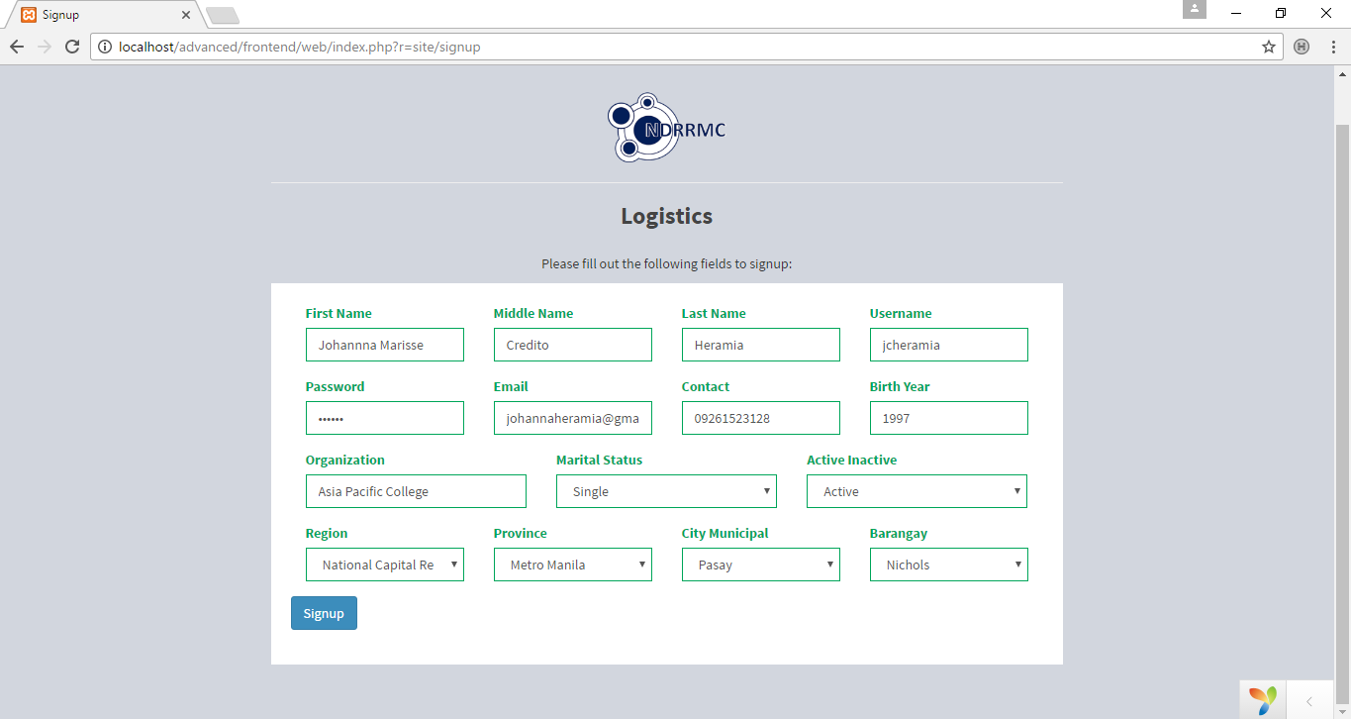Fill up the following fields in the signup form.

Figure 5, Signup Form

***Login***

If the user has an account, he or she must login first before accessing the main page.

1. Go to <http://localhost/advanced/frontend/web/index.php?r=site/login>
2. Fill up the *username* and *password* form.
3. 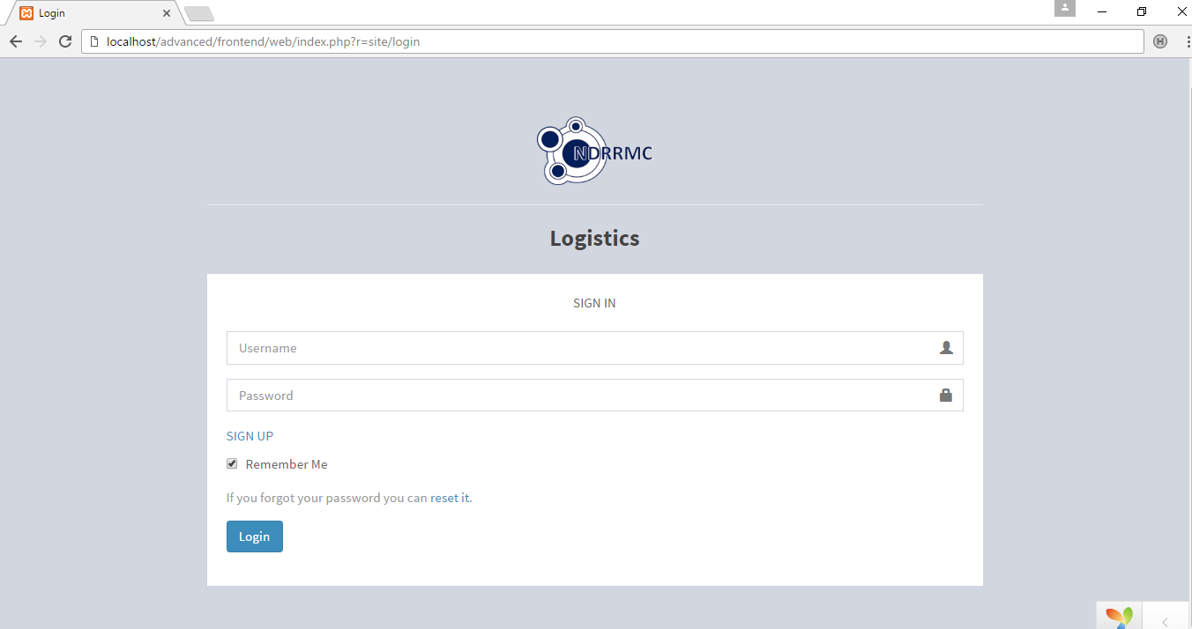Click the ‘Login’ button.

Figure 5.1, Logging in

1. 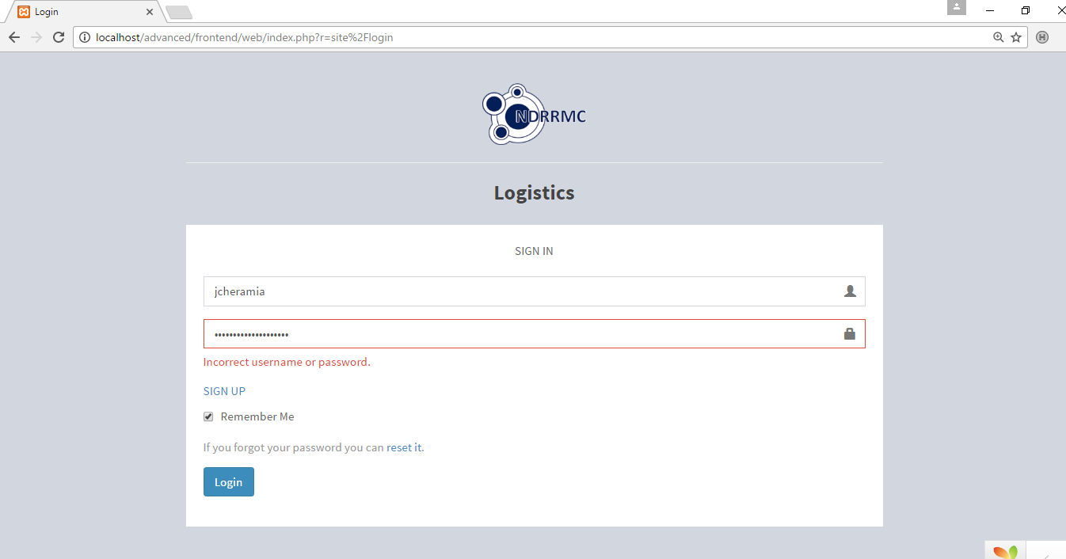If the *username* and *password* does not match, then it will give an error message

*Figure 5.2, Login error message*

***Main Page***

1. Once creating an account or logging in is successful, then it will display the main page.

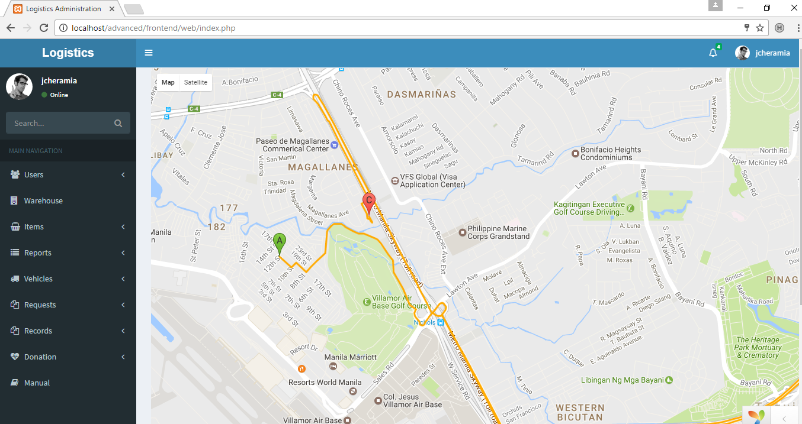

*Figure 5.3, Main Page of Administrators*

***Map***

The map section includes the information in areas, establishments, nearest supplies, and so on

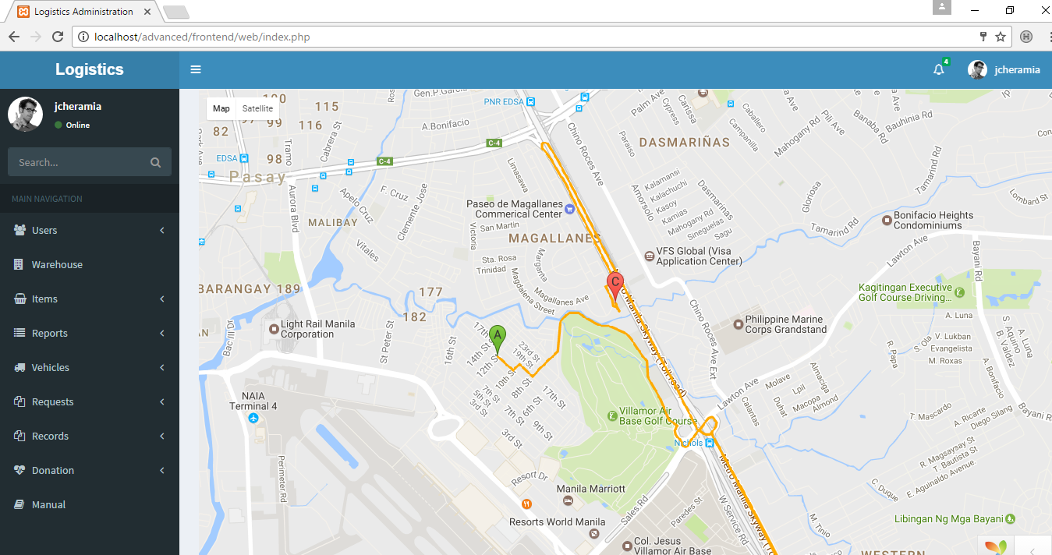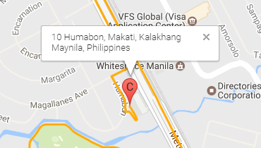

1. Click the pinned areas to see the information

*Figure 5.4, Map View*

1. 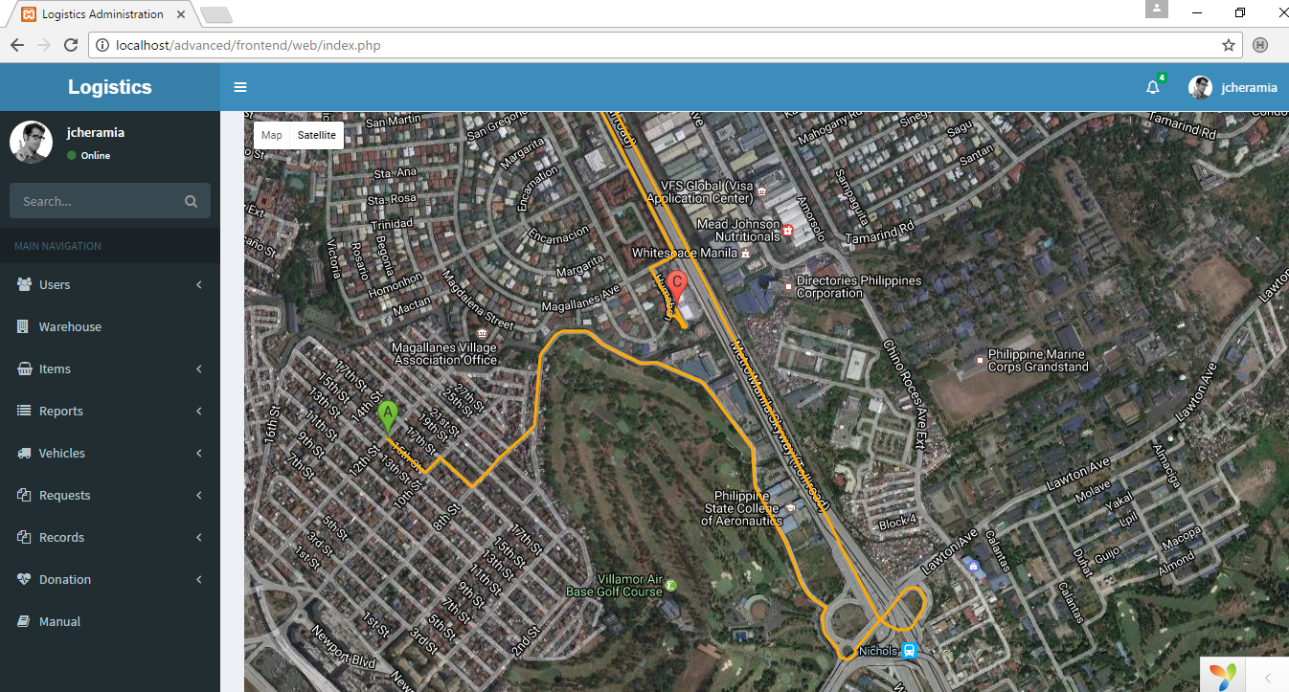To see as satellite view, click on the satellite button.

*Figure 5.5, Satellite View*

***Records of Users***

1. Click the dropdown to see the types of user.
2. If for example, you click the ‘National Admins’, then you will see the lists of national administrators.
3. To see the detailed view of user, click the icon in the right side of every record.

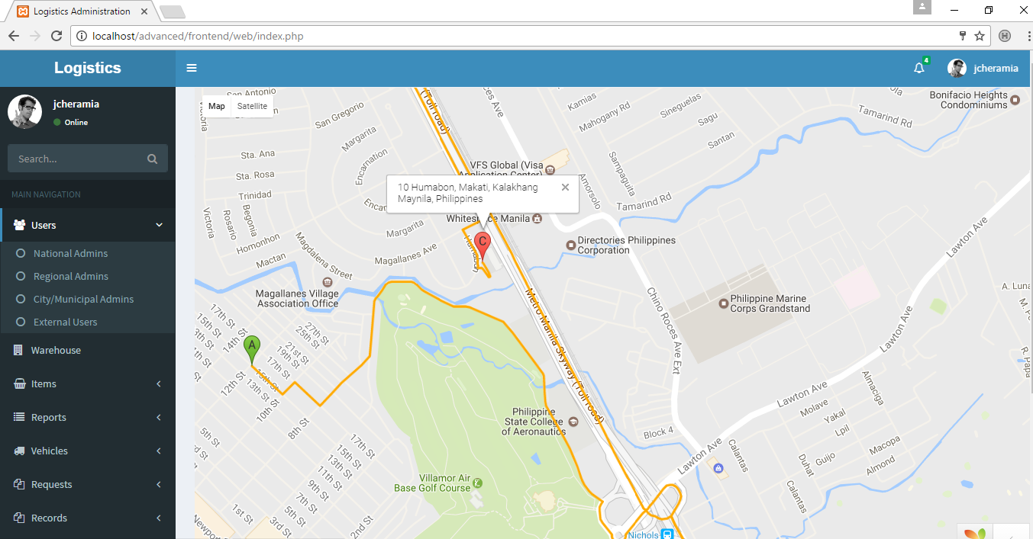

*Figure 5.6, Types of Users*

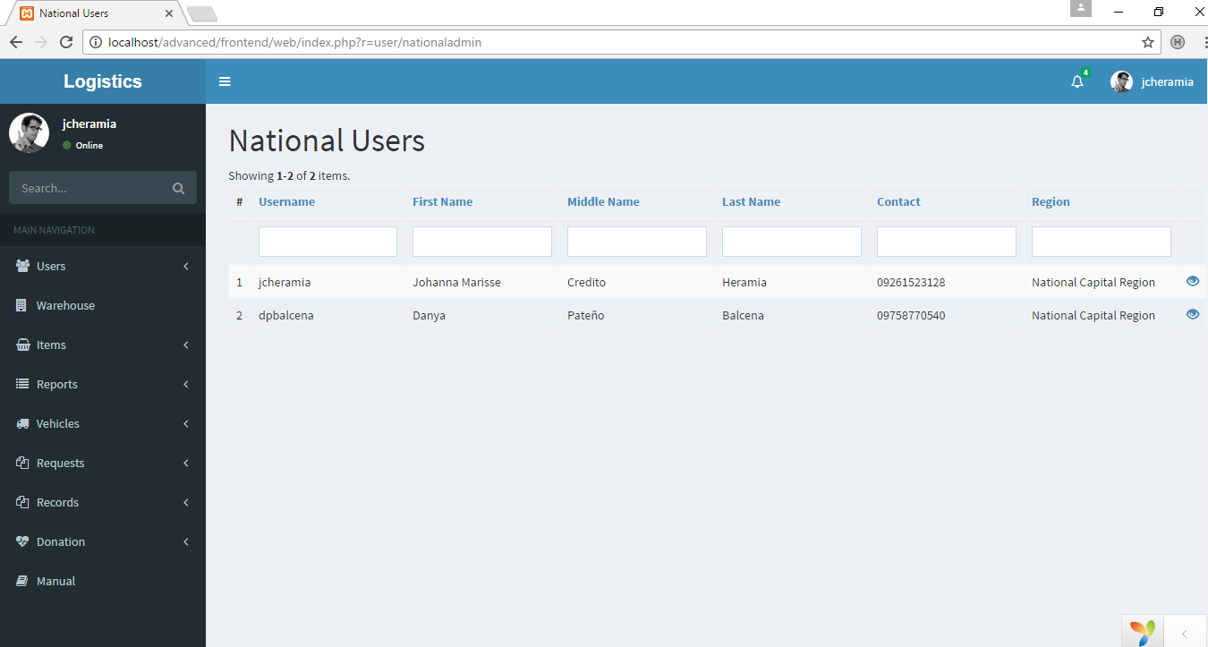

Figure 5.7, Records of National Users

***Reports***

1. To see the reports, click the dropdown ‘Report’ and click if Expiration Report, Calendar or Incoming Supplies.
2. For example, in Calendar, the user can see the list of tasks that he or she needs to do in a calendar format.
3. If the user wants to see it by week, click the ‘week’ button.
4. If the user wants to move to different months, click the arrow buttons.

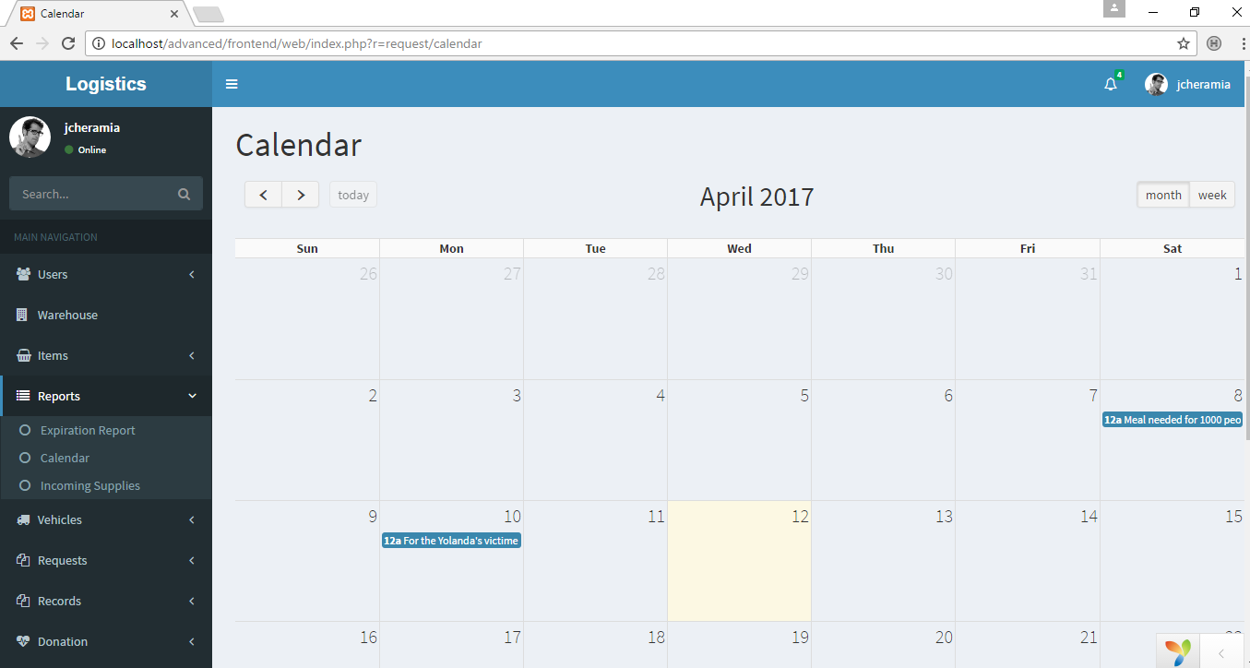

Figure 5.8, Calendar

***Requests***

1. To see the list of Pending requests, click the ‘Pending’.
2. To confirm the pending request, click the ‘Confirm’ button. After confirming the request, it will automatically go to the ‘Confirmed’ page.
3. To view the details of the request, click the icon.

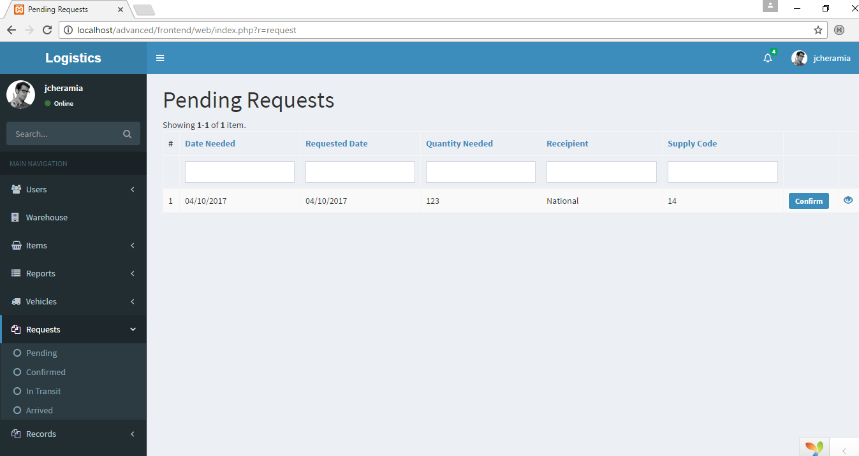

Figure 5.9, Pending requests

1. Once the ‘Confirm’ button is clicked, the user will go to the ‘Confirmed’ page.
2. If the requested supply is ready to go, click the ‘Send’ button.

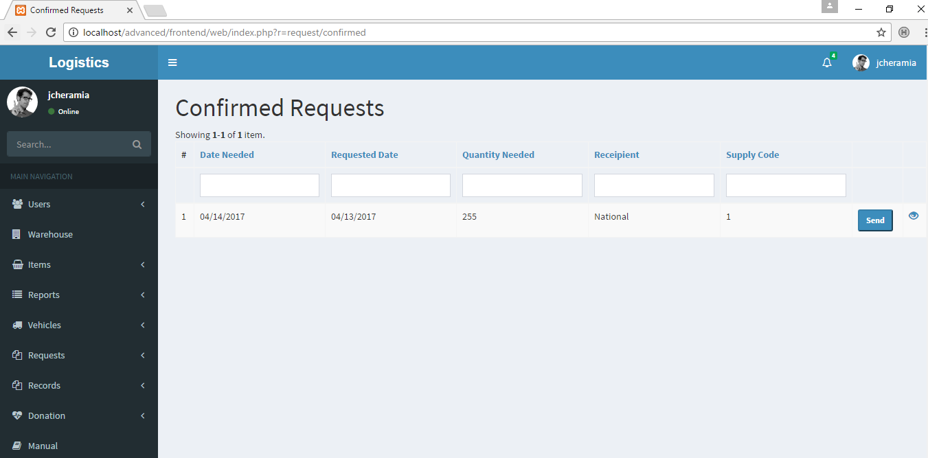

Figure 5.10, Confirmed Requests

1. Once the ‘Send’ button is clicked, or if the requested supply is ready to dispatch, a form will pop up. This form contains kind of transportation to be used, name of the vehicle, plate number of vehicle and name of the person in-charged. This will be populated by the requestee.
2. 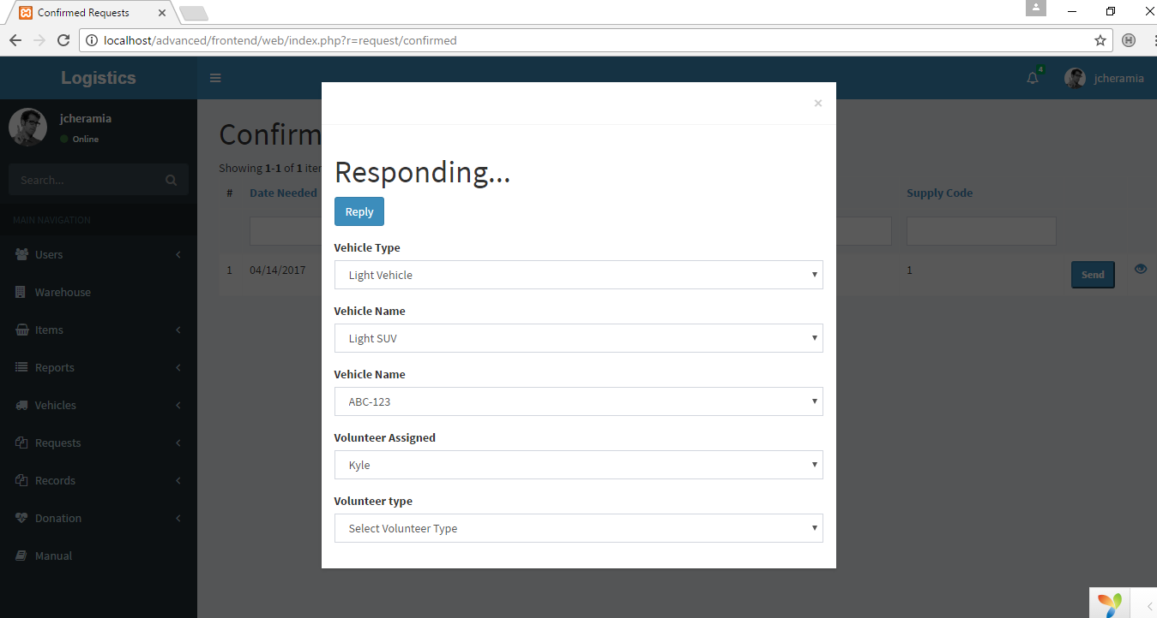Once the requestee is done inputting, click the ‘Reply’ button to save the reply. This will be seen by the requestor. Also, once the ‘Reply’ button is clicked, the status will now become ‘Transit’.

Figure 5.11, Respond Form

1. This is the In-Transit page.
2. The ‘Arrived’ button will be clicked by the requestor. Once the ‘Arrived’ button is clicked (means that the requested has arrived), the status will be change to ‘Delivered’.

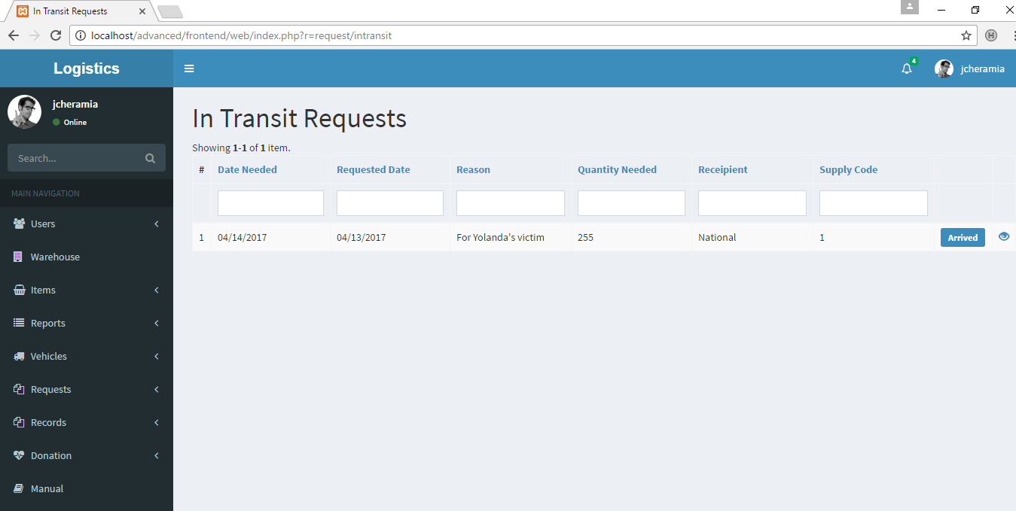

Figure 5.12, In-Transit Page

***Supplier***

1. In creating records of suppliers, Click the ‘Records’ in the left side menu.

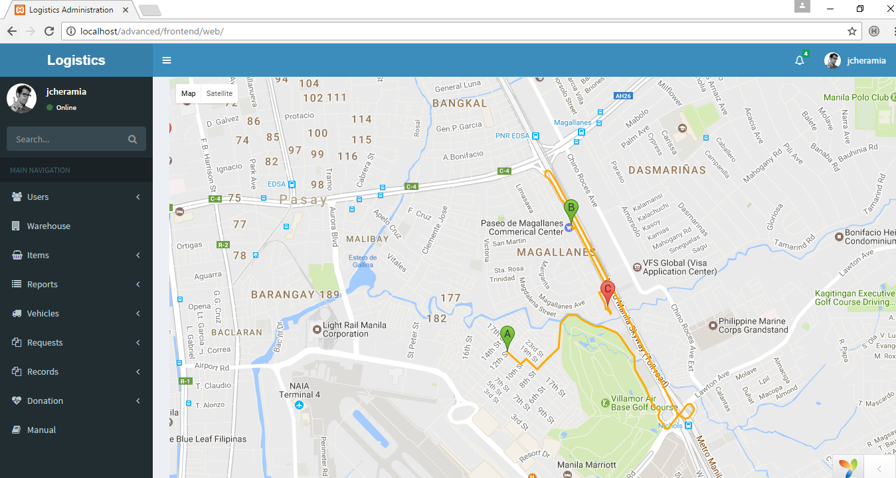

1. 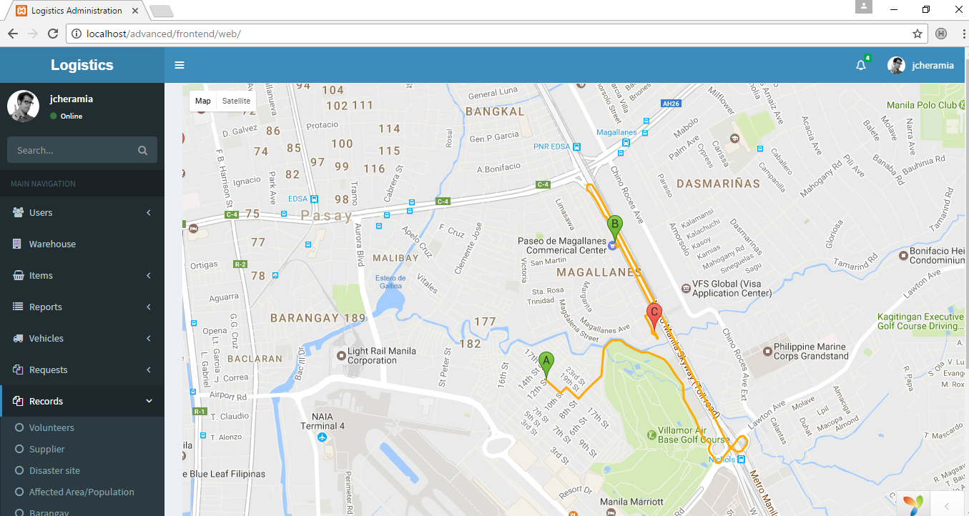Click the ‘supplier’

Figure 5.13, Supplier

1. Once the ‘Supplier’ has been clicked, page of records of supplier will appear.
2. Click the ‘Create Supplier’ to create supplier.
3. Click the eye like icon on the right side of the record to view.
4. Click the pencil like icon on the right side of the record to update.
5. Click the trash can like icon on the right side of the record to delete.

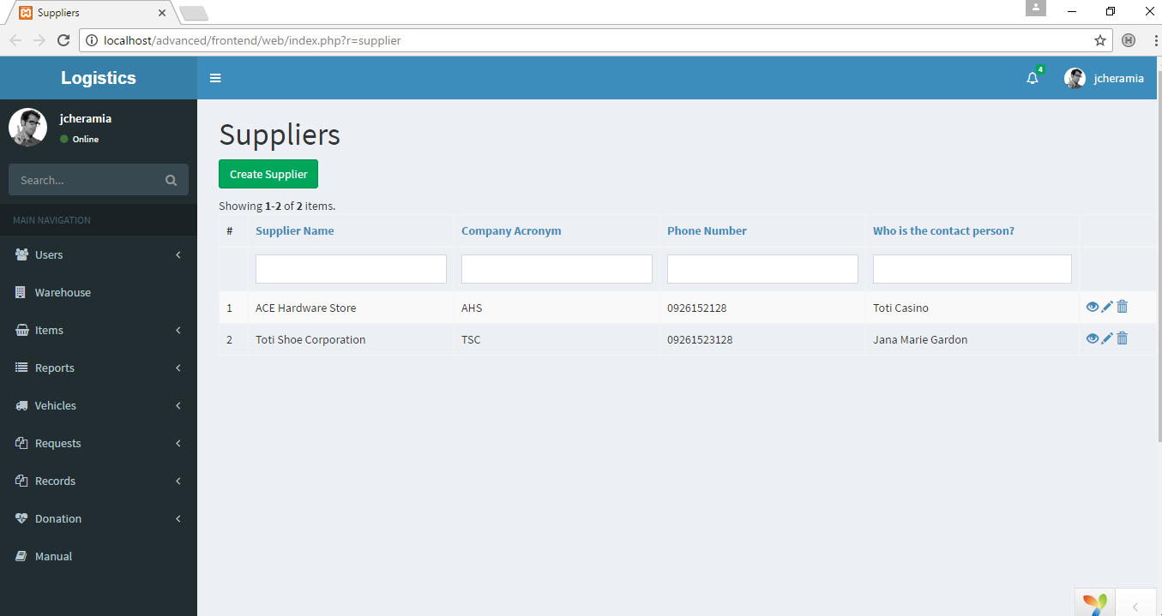

Figure 5.14, Adding, viewing, updating and deleting supplier

1. If the ‘Create Supplier’ is clicked, a form will be seen.

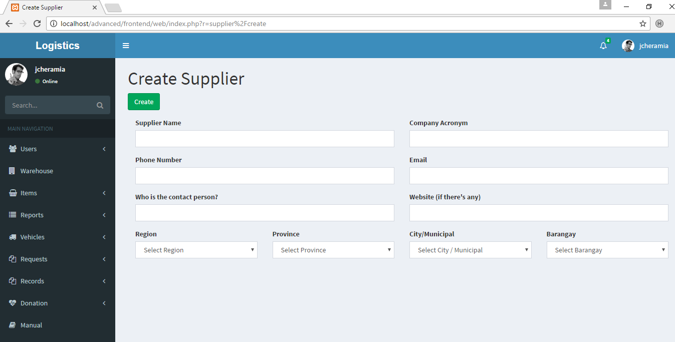

Figure 5.14, Creating supplier

1. In filling out the form, when selecting the region, province, city and barangay, it will automatically choose the place under a specific place. For example, if the person chooses the Metro Manila in province, it will only show the city or municipal under Metro Manila.

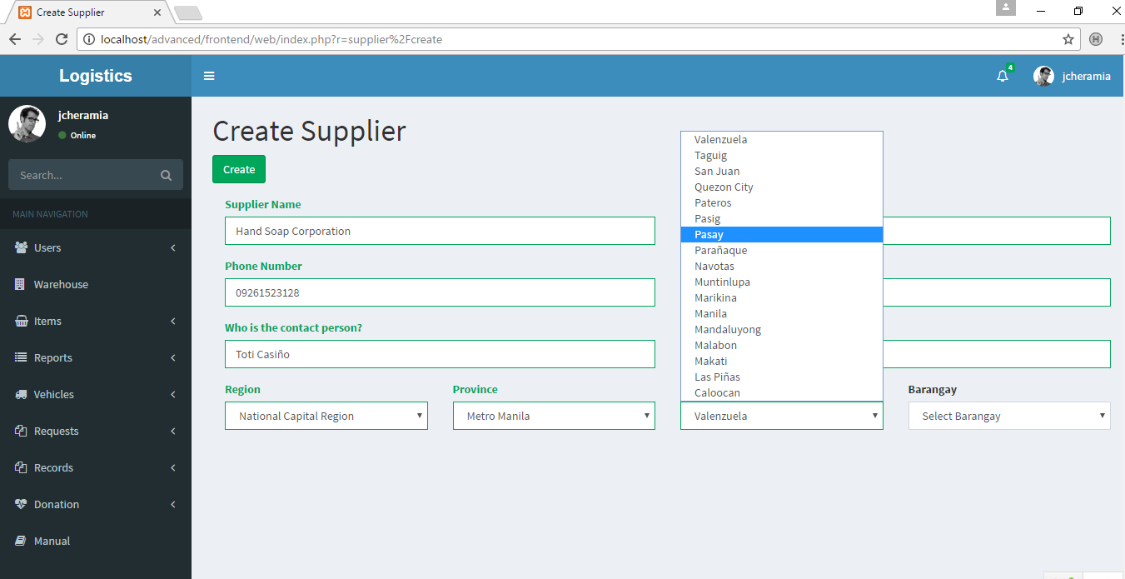

Figure 5.15, Selecting places

**Logging out**

1. In logging out, click your username on the upper right hand of the web.
2. Click the ‘Sign out’ button to log out.

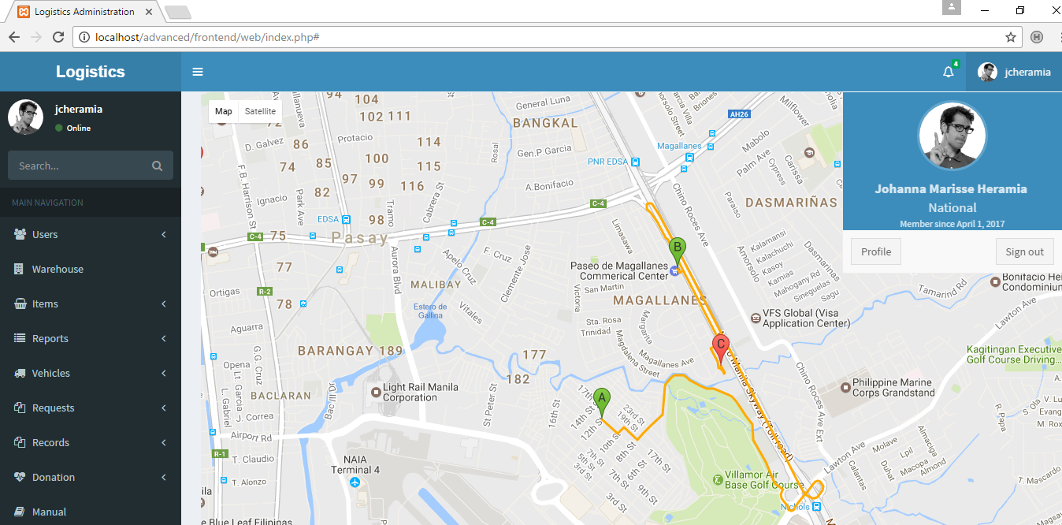

Figure 5.16, Log out

# **Conclusion and Recommendations**

The following recommendations are based from different sources. All our based-on experience and reflection about the system, what worked and what can be the next steps to improve the performance of the system.

* Be clear about the purpose of the system
* Begin with a clear understanding about the process of the system
* Develop clear process of the system
* Research on the related system to know what to improve in creating system
* Be clear about the target audience
* Consider making or researching about the data needed
* Design a system that is easy to navigate, easy to use and graphically clear

# **Lessons Learned**

Based on our experience, to be able to finish a successful system, a team must have focus, determination and have good communication with each other. Those are the three things we realized as a team while doing the project. Focusing on the things you need to be done includes having a quality checked project; a project that scope, cost, time and quality are balanced. Knowing the scope of the project and avoiding unnecessary changes while in the middle of the project helps you focus on your objective. Determination comes when you try your best even if it seems impossible because the impossible is possible if we believe so. Lastly, having a good communication with the team leads to a better project planning and implementation. A team communication skills helps ensure project’s success wherein it builds strong relationship among team members, thus we ensure sharing of good and better ideas and respects each other’s opinion. As a project manager, knowing the attitude of your team member is important and knowing the organization structure you are working is a must because your work involves them. Overall, the project will be successful when it was completed on time, thus a proper time, scope and quality.

# **APPENDIX A – RELEVANT SOURCE CODE**

**namespace and use keywords**

The following are the sample codes for models. In this case, the user model is being used.

**namespace** common\models;  
  
**use** Yii;  
**use** yii\base\NotSupportedException;  
**use** yii\behaviors\TimestampBehavior;  
**use** yii\db\ActiveRecord;  
**use** yii\web\IdentityInterface;

*CODE 1*

Using namespaces, it can create better references to code and prevent naming collisions when using code from multiple sources: a third-party library’s User class can be kept distinct from site’s User class. In this case, code is assigned to a namespace using namespace keyword. In addition, there are also frontend\models and backend\models, and by using namespace, it will prevent collision or the code will know that the exact model will be in common\models.

The use keyword here is like import. It must be used for other code to use some classes.

**Getting primary key**

**public function** getId()  
{  
 **return** $this->getPrimaryKey();  
}

*CODE 2*

The CODE 2 is a function that is used to get unique or the primary key, in this case, the primary key for user table.

**Generating authentication key**

**public function** generateAuthKey()  
{  
 $this->**auth_key** = Yii::*$app*->**security**->generateRandomString();  
}

*CODE 3*

The code 3 function is used to generate authentication keys when user is creating an account. This also will protect the account of user because even the developers cannot see the password of a user because the authentication has been generated for the user automatically. In addition, the Yii::$app is a shorthand for saying that the $app variable of the Yii class.

**Rendering pages**

**public function** actionHeavyvehicle()  
{  
 $searchModel = **new** VehicleSearch();  
 $dataProvider = $searchModel->search(Yii::*$app*->**request**->**queryParams**);  
 $dataProvider->**query**->andFilterWhere([**'type'**=>**'Heavy Vehicle'**]);  
  
 **return** $this->render(**'heavyvehicle'**, [  
 **'searchModel'** => $searchModel,  
 **'dataProvider'** => $dataProvider,  
 ]);  
}

*CODE 4*

Code 4 is sample function that renders pages with records. The VehicleSearch() is a model for search purposes. The function andFilterWhere is used to filter data. In this case, the records that will only show the page is with the type of Heavy Vehicle.

**public function** actionSample($id)  
{  
 **return** $this->redirect([**'sample'**]);  
}

*CODE 5*

CODE 5 is used to render static pages. In this case, it will render the ‘sample’ page.

**Creating record**

**public function** actionCreate()  
{  
 $model = **new** Vehicle();  
  
 **if** ($model->load(Yii::*$app*->**request**->post()) && $model->save()) {  
 **return** $this->redirect([**'view'**, **'id'** => $model->**plate_number**]);  
 } **else** {  
 **return** $this->render(**'create'**, [  
 **'model'** => $model,  
 ]);  
 }  
}

*CODE 6*

Code 6 is used to add or create data. If creating is successful, it will redirect to the ‘view’ page. The ‘view’ page contains the detailed view of the record that was created. If failed, then it will remain on the same page, which is the ‘create’ page. One of the reasons why saving the data fails is because there are some required fields that the user fails to fill.

**Sample fields**

<**div class="col-md-3"**>  
 **<?=** $form->field($model, **'plate_number'**)->textInput([**'maxlength'** => **true**]) **?>**</**div**>

*CODE 7*

Code 7 is a sample field that is used in creating records.

<**div class="col-md-3"**>  
 **<?=** $form->field($model, **'type'**)->dropDownList(  
 [  
 **'Light Vehicle'** => **'Light Vehicle'**,  
 **'Medium Vehicle'** => **'Medium Vehicle'**,  
 **'Heavy Vehicle'** => **'Heavy Vehicle'**,  
 ], [**'prompt'** => **''**]) **?>**</**div**>

*CODE 8*

Code 8 is a sample field used in creating records and in this case, drop down is being used if there are certain fields that requires fixed information that the user cannot be changed.

<**div class="col-md-3"**>  
 **<?=** $form->field($model, **'barangay'**)->dropDownList(  
 ArrayHelper::*map*(Barangay::*find*()->all(), **'name'**, **'name'**),  
 [  
 **'prompt'** => **'Select Barangay'**,  
  
 ]);**?>**</**div**>

*CODE 9*

Code 9 is used if the data required will come from different model. In this case, the ‘barangay’ attribute from the Vehicle table requires the Barangay model’s ‘name attribute or property.

<**div class="col-md-6"**>  
 **<?=** $form->field($model, **'comment'**)->textarea([**'rows'** => 4]) **?>**</**div**>

*CODE 10*

Code 10 is used if the user’s input requires large amount of information or texts. It uses the textarea function with four rows.

<**div class="col-md-3"**>  
 **<?=** $form->field($model, **'region'**)->dropDownList(  
 ArrayHelper::*map*(Region::*find*()->all(), **'name'**, **'name'**),  
 [  
 **'prompt'** => **'Select Region'**,  
 **'onchange'** => **'$.post("index.php?r=supplier/list_province&id='**.**'"+$(this).val(),function(data){  
 $("select#province").html(data);  
 });'** ]);**?>**</**div**>

*CODE 11*

<**div class="col-md-3"**>  
 **<?=** $form->field($model, **'province'**)->dropDownList(  
 ArrayHelper::*map*(Province::*find*()->all(), **'name'**, **'name'**),  
 [  
 **'prompt'** => **'Select Province'**,  
 **'id'** => **'province'**,]);**?>**</**div**>

*CODE 12*

**public function** actionList_province($id){  
  
 $countprovince = Province::*find*()->where([**'region'** => $id])->count();  
 $province = Province::*find*()->where([**'region'** => $id])->orderBy(**'name DESC'**)->all();  
 **if**($countprovince > 0){  
 **foreach** ($province **as** $result) **echo "<option value = '"**.$result->**name**.**"'>"**.$result->**name**.**"</option>"**;  
 }**else**{  
 **echo "<option>-</option>"**;  
 }  
}

*CODE 13*

Code 11 and 12 is a dropdown field. It is used in *filtering related data*. For example, in the Code 11, the region, once the user click the National Capital Region, it will call the Code 13 function. The Code 13 function will list all the provinces that are related to National Capital Region which is Metro Manila that will only be shown to the Code 12, the province field.

$directionsRequest = **new** DirectionsRequest([  
 **'origin'** => $home,  
 **'destination'** => $school,  
 **'waypoints'** => $waypoints,  
 **'travelMode'** => TravelMode::***DRIVING***]);

*CODE 14*

Code 14 is used in mapping in displaying the routes to take from the origin to the destination.

# **APPENDIX B – REFERENCES**

Amna, Shahzadi. *Logistics Support and Its Management during Disaster Relief Operations.*  Retrieved from [http://www.academia.edu/5264828/Logistics_Support_and_Its_Managemen t_during_Disaster_Relief_Operations](http://www.academia.edu/5264828/Logistics_Support_and_Its_Managemen%09t_during_Disaster_Relief_Operations)

*ASEAN launches disaster emergency logistics system.* Retrieved from [http://www.dtinews.vn/en/news/017/26562/asean-launches-disaster- emergency-logistics-system.html](http://www.dtinews.vn/en/news/017/26562/asean-launches-disaster-%09emergency-logistics-system.html)

*Assessment of Disaster Risk Reduction and Management (DRRM) at the Local Level. (2014).* Retrieved from [http://www.coa.gov.ph/phocadownloadpap/userupload/DRRM/Assessment_ of_DRRM_at_the_Local_Level.pdf](http://www.coa.gov.ph/phocadownloadpap/userupload/DRRM/Assessment_%09of_DRRM_at_the_Local_Level.pdf)

*Disaster Risk Reduction Resource Manual. (2008).* Retrieved from [http://www.deped.gov.ph/sites/default/files/Disaster%20Risk%20Reduction %20Resource%20Manual.pdf](http://www.deped.gov.ph/sites/default/files/Disaster%20Risk%20Reduction%09%20Resource%20Manual.pdf)

Haghani, Afshar. *Supply Chain Management in Disaster Response.* (2009 September). Retrieved from http://www.mautc.psu.edu/docs/UMD-2008-01.pdf

Humanitarian Action unit, Regional Office for the Western Pacific, World Health Organization. *Pocket Emergency Tool. (2012).* Retrieved from http://ro11.doh.gov.ph/pdf/PET.pdf

Jang, Yuan, Huang, Zhao. *Logistics for Large-Scale Disaster Response: Achievements and Challenges. (2012).* Retrieved from <https://www.researchgate.net/publication/254051386_Logistics_for_Large-> Scale_Disaster_Response_Achievements_and_Challenges

Parnell, Rosemary.*American Red Cross Disaster Logistics.* Retrieved from <http://www2.isye.gatech.edu/humlog09/program/disasterredcrossparnell.pdf>

*Philippines National Disaster Risk Reduction and Management Council (NDRRMC).* Retrieved from http://www.un-spider.org/links-and- resources/institutions/philippines-national-disaster-risk-reduction-and- management-council-ndrrmc

*Relief Supply Logistics in the Greatest East Japan Earthquake. (2013 July).* Retrieved March 3, 2017, from http://www.wctrs-society.com/wp/wp- content/uploads/abstracts/rio/selected/2847.pdf

*Sahana Foundation.* Retrieved from <https://sahanafoundation.org/about/>

The USDA Forest Service International Programs Disaster Assistance Support Program. *Field Operations Guide for Disaster Assessment and Response. (2005 September).* Retrieved March 3, 2015, from <https://www.usaid.gov/sites/default/files/documents/1866/fog_v4_0.pdf>

Uichanco, Joline Anne V. *EVP Terminal Report: Operations research for disaster preparedness and response. (2015 January 7).* Retrieved from <http://evpcommittee.ph/images/FeaturedProjects/Disaster_Model.pdf>

Ullman, Larry. *The Yii Book.* (2015).

*USAID Office of U.S. Foreign Disaster Assistance. Guidelines for Proposals. (2012 October).* Retrieved March 3, 2017, from [https://www.usaid.gov/sites/default/files/documents/1866/guidelines_for_pro posals_2012.pdf](https://www.usaid.gov/sites/default/files/documents/1866/guidelines_for_pro%09posals_2012.pdf)

# **APPENDIX C – DEFINITION OF TERMS**

**Stored goods** – These are goods that are stocked by municipalities or by citizen in preparation for disasters

**NDRRMC** (National Disaster Risk Reduction Management Council) – This council is responsible for ensuring the protection and welfare of the people during disasters or emergencies.

**OCD** (Office of Civil Defense) – Government agency that administer a comprehensive national civil defense and disaster risk reduction and management program.

**Event table** – Event tables allow you to store, retrieve and process events in a database table-like structure.

**Entity Relationship Diagram** -  is a graphical representation of an information system that shows the **relationship** between people, objects, places, concepts or events within that system.

# **APPENDIX D – CURRICULUM VITAE**

